Video 1 : Introduction to computer network and ip addresses

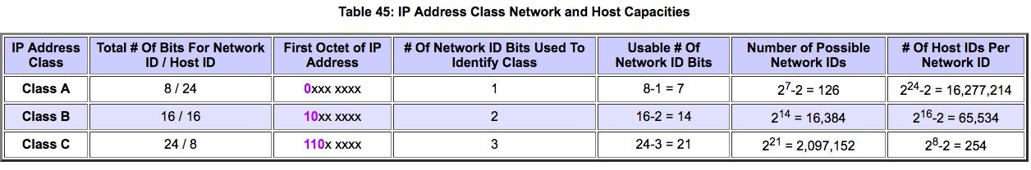

Video 2 : Types of Casting, Unicast and Broadcast

BroadCasting -

1. Limited BroadCasting : broadcast to all hosts in same network

Limited broadcast address : 255.255.255.255

1. Directed BroadCasting : broadcast to all hosts in different network

Directed broadcast address : otherhostid.all1’s eg. 20.255.255.255

Video 3 : Subnets, Subnet masking, Routing

Subnetting –

1. Wastageof ip address ( 2 per subnet)
2. For more than one match, go for longest subnet mask eg. Prefer/15 to /12
3. Doesn’t match to any entry goes to default (0.0.0.0 sm 0.0.0.0)

Video 4 : Variable length subnet masking

200.1.2.0 – Three networks of 128,64,64. Other than soln below nid’s can be(0,64,128)

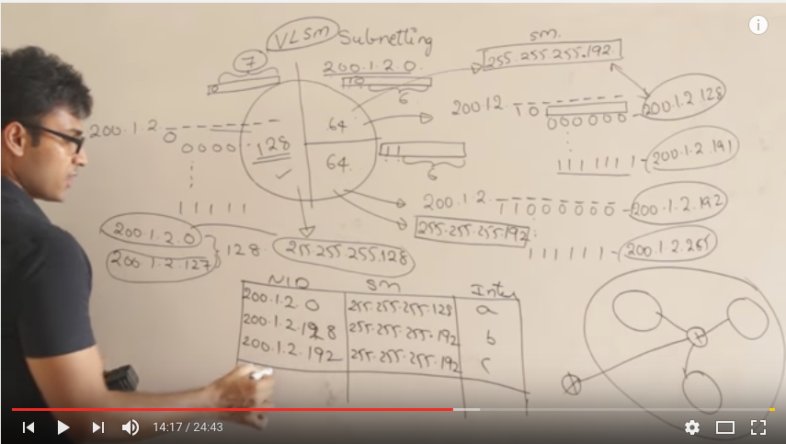

Video 5 : Subnet masking questions

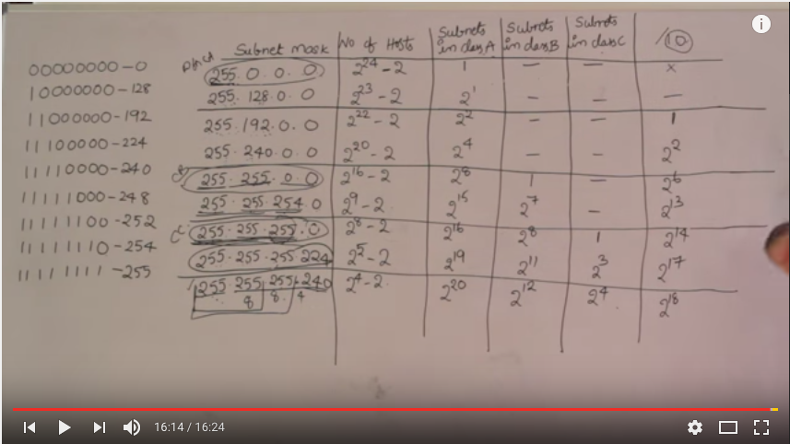

Video 6 : Classless InterDomain Routing

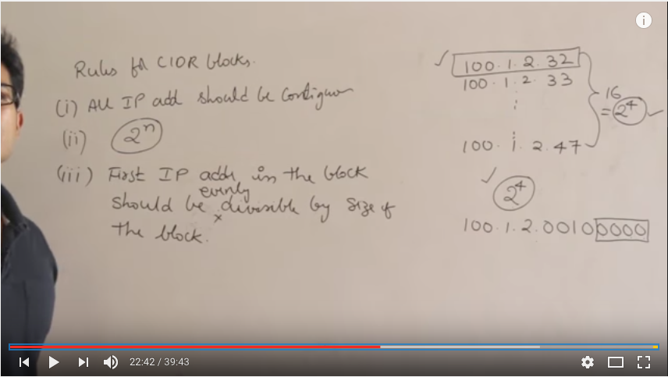

Video 7 : Subnetting, VLSM in CIDR

Based on above Concepts

Video 8 : Prolems on Subnet mask

Should be solved

Video 9 : Supernetting and aggregation

I.Continious, II.Same size, III.First NID/size of block

